ACCESS CONTROL LIST
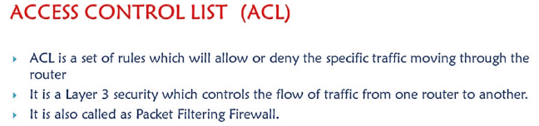
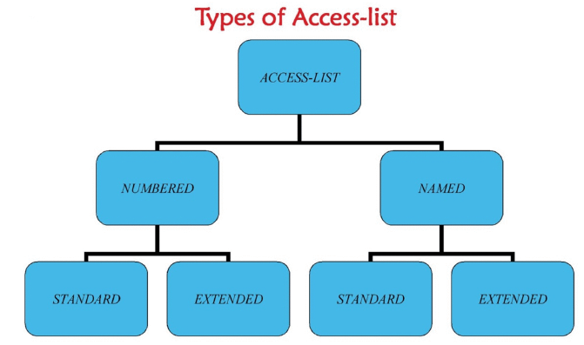
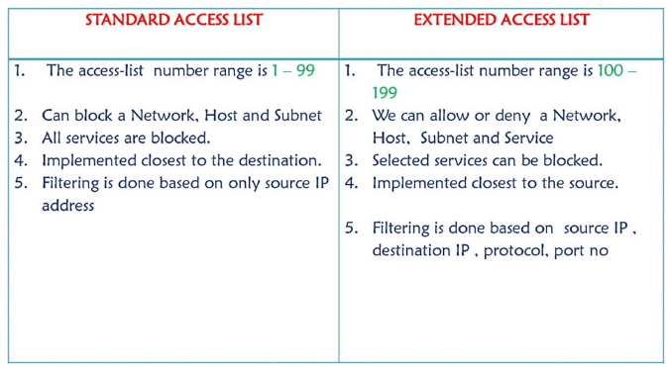
The main advantage we get in named ACL is we can add a specific line or delete a specific line form the list of rules written which is not available in numbered access list
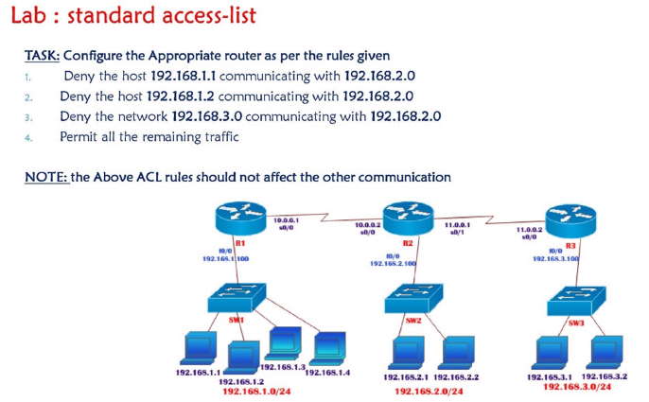
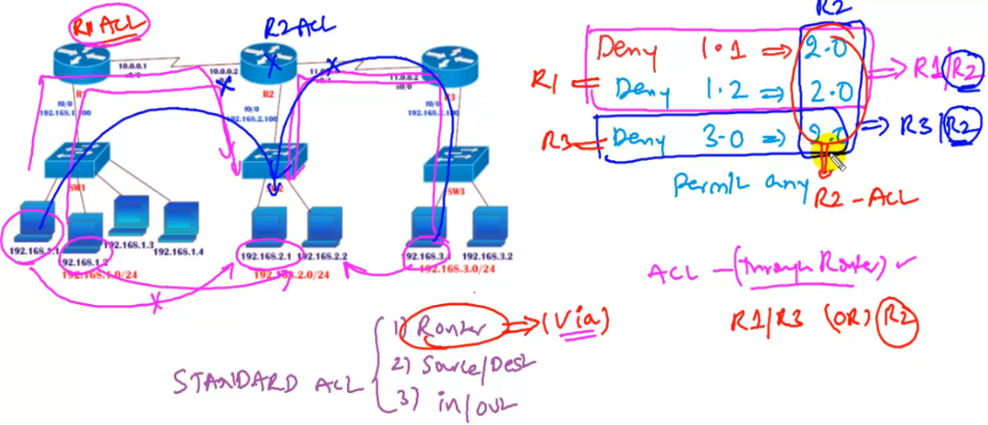
We can implement ACL on R2 since it is common or we can also implement ACL on R1 as well as R2
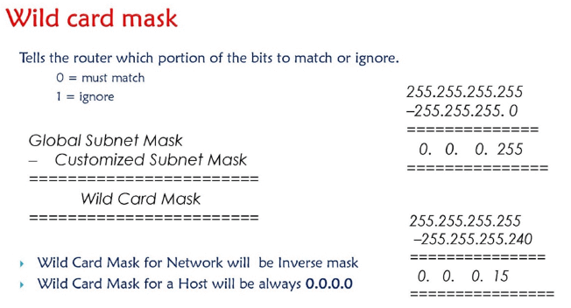

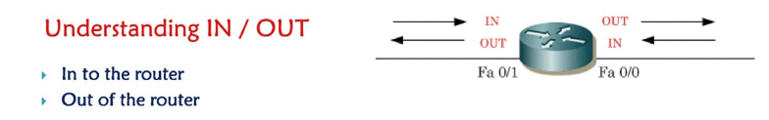
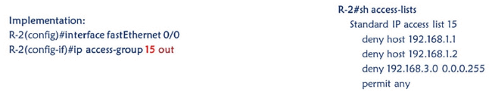
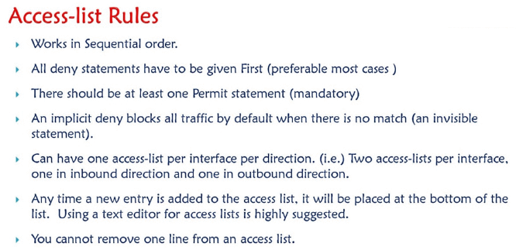
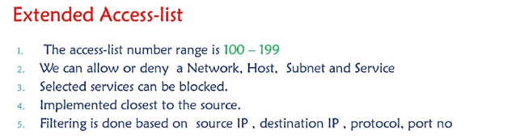
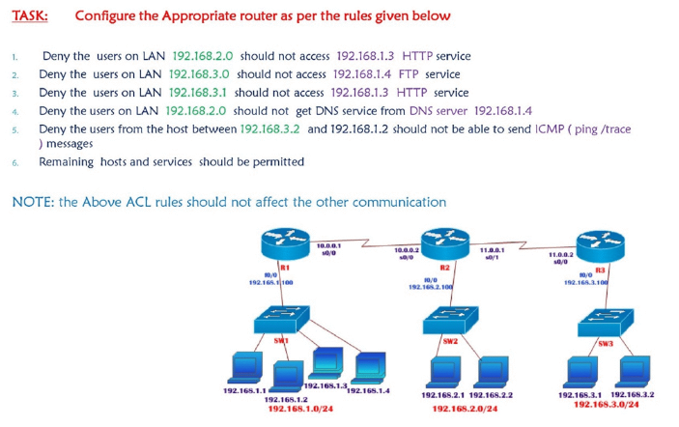
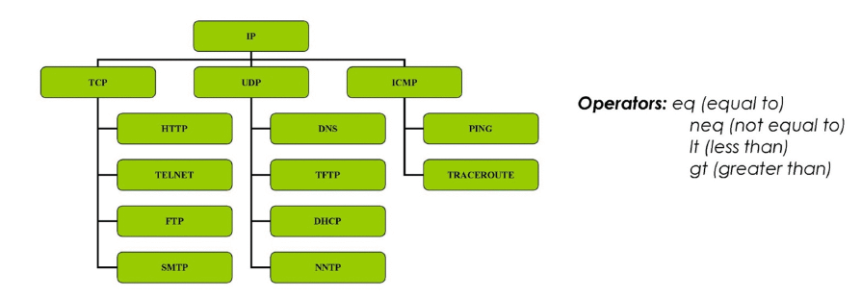
Eq = match only the packets which is equal to 80 example
Neq= other than 80 deny everything
Lt = deny/allow all port numbers lesser than 2000
Gt= deny/allow all port numbers greater than 2000
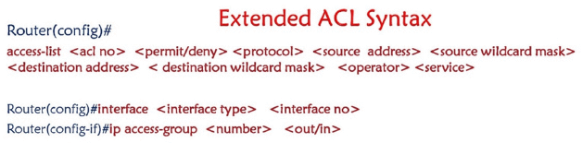
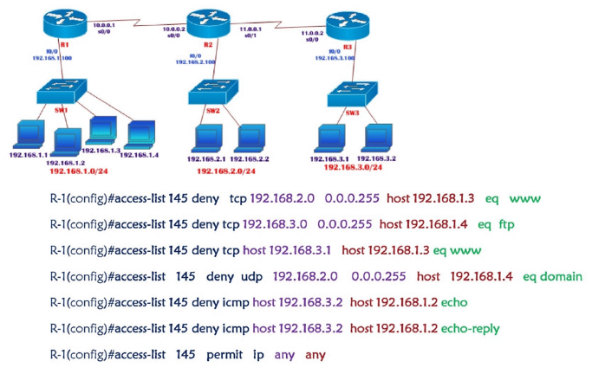
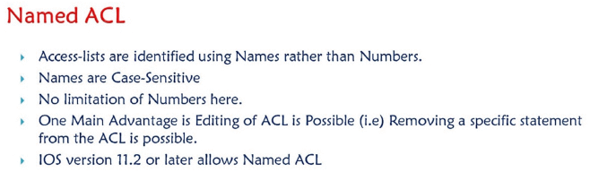
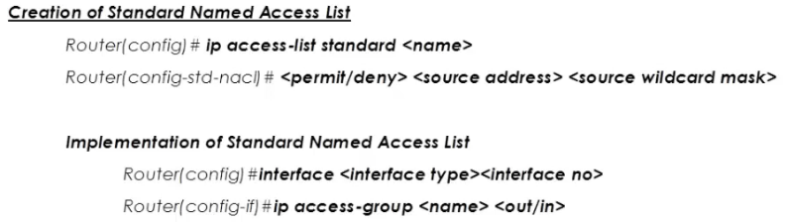

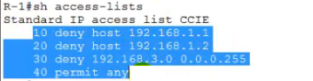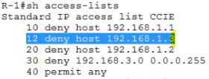
By default whenever we create acl sequence numbers (always in multiples of 10)will be added by default it is use to identify the acl s written , now lets say I want to add a new rule inbetween then I will use these sequence numbers , usually when I add a new acl it will add in the last but if I want to add it inbetween then R1() ip access-list extended CCIE
If you want to remove any line then 12 deny host 192.168.1.3
R1() ip access-list extended CCIE
No 20
So this way we can selectivily add or remove a specific line in case of ACL

IPV6
IPV6 was introduced to overcome the shortage of IPV4 addresses
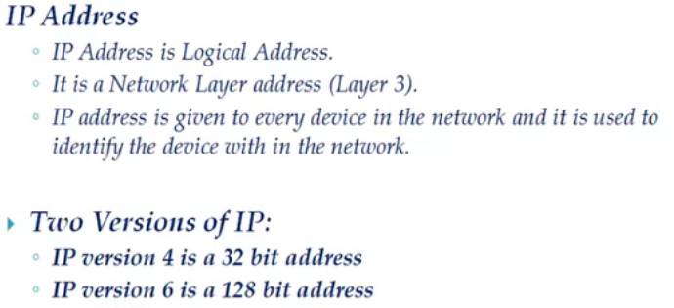

What is the Need of IPV6 address - We have 2 ^ 32 = 4.3 billion ip addresses but these ip addresses are not enough to meet the growing requirements , as the internet is growing at a very faster rate .

http://www.ipv6now.com.au/primers/IPv6Myths.php

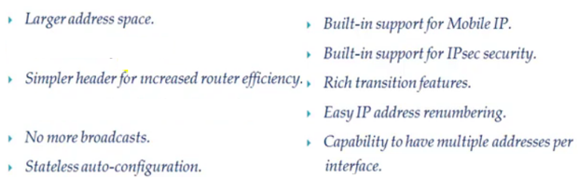

Global prefix interface ID

Unicast , Multicast and Anycast

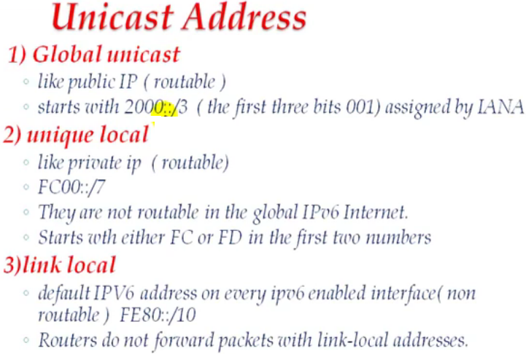
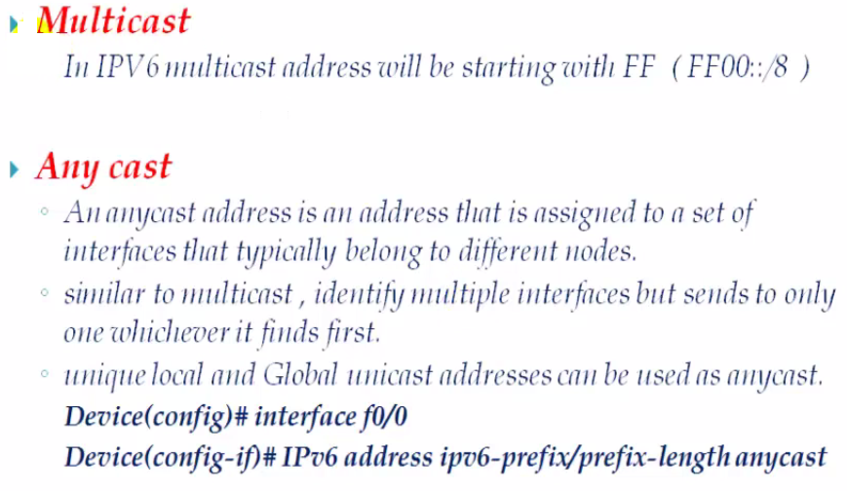
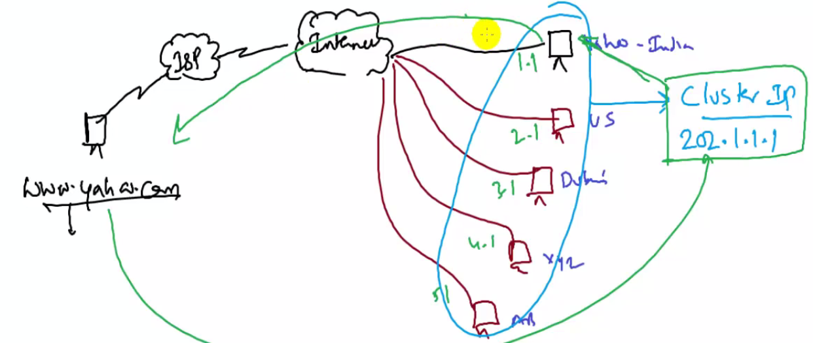
Stateless auto configuration – EUI 64 bit format

Assigning IPV6 address
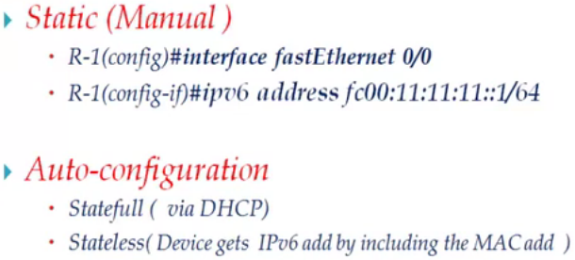
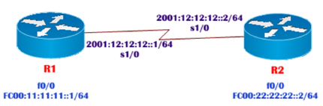

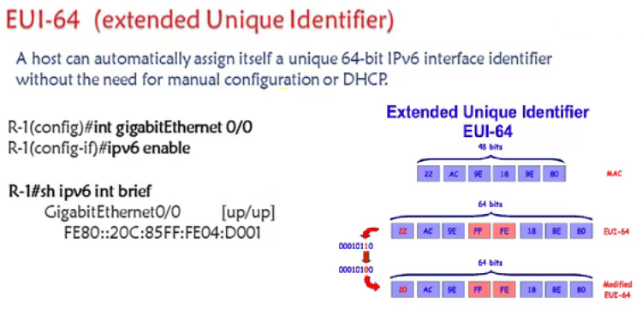

IPV6 routing types – Static , RIP ng , OSPF V3 , EIGRP – IPV6 unicast routing
Static routing
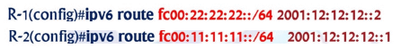

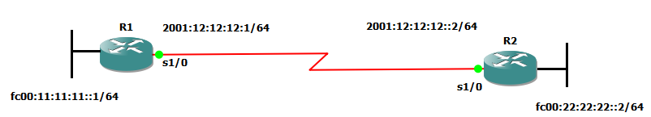

interface serial 1/0
ipv6 address 2001:12:12:12::1/64
no sh
exi

interface fastethernet 0/0
ipv6 address fc00:11:11:11::1/64
no sh
no keepalive
exi

ipv6 route FC00:22:22:22::/64 2001:12:12:12::2
exi

R2

interface serial 1/0
ipv6 address 2001:12:12:12::2/64
no sh
exi

interface fastethernet 0/0
ipv6 address fc00:22:22:22::2/64
no sh
no keepalive
exi

ipv6 route FC00:11:11:11::/64 2001:12:12:12::1
exi

